~Asia-China-Mirror-Han-Philospher and student and rampant animals

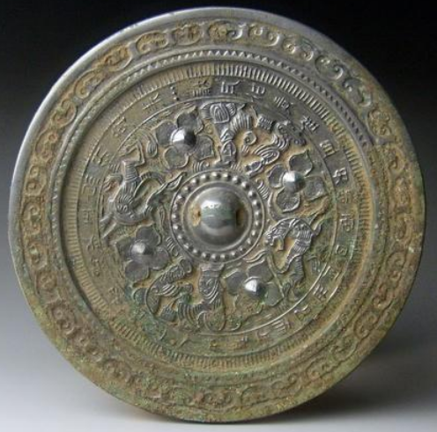

This unusual mirror show two views of a philosopher and a student separated by rampant animals. The theme suggests the pursuit of study amidst the flight of time as it runs continuously around the central boss. In the outer band is a lengthy poems relating to this theme. Around the rim of the mirror is a band of cloud lozenges and o the inner band is hachuring. It would appear that the philosopher is preseting the poem to the student, who looks attentively at his master.

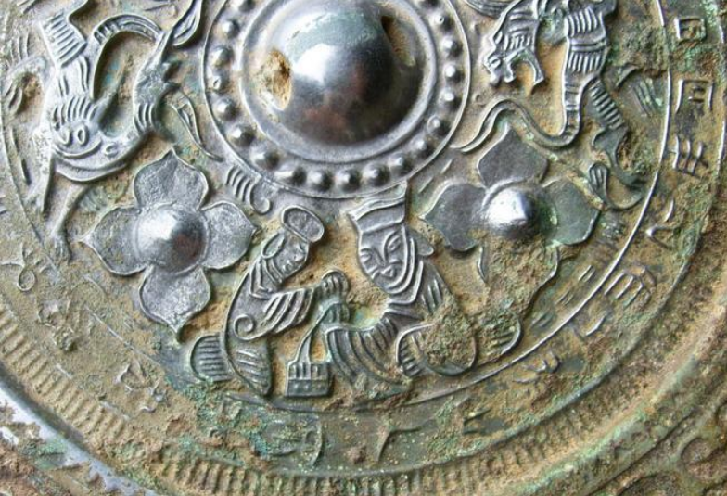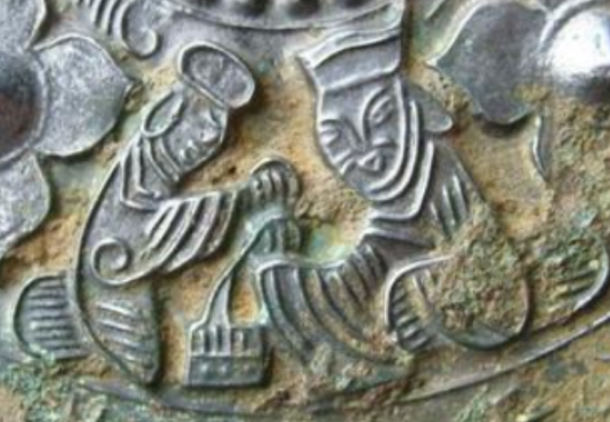

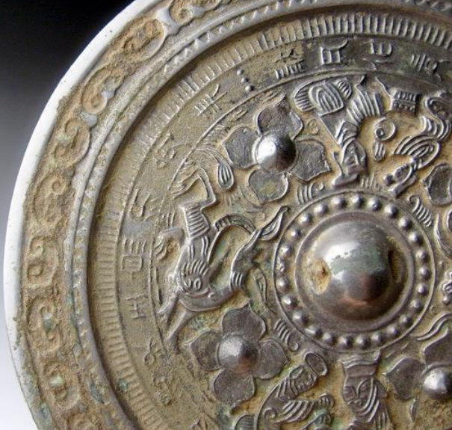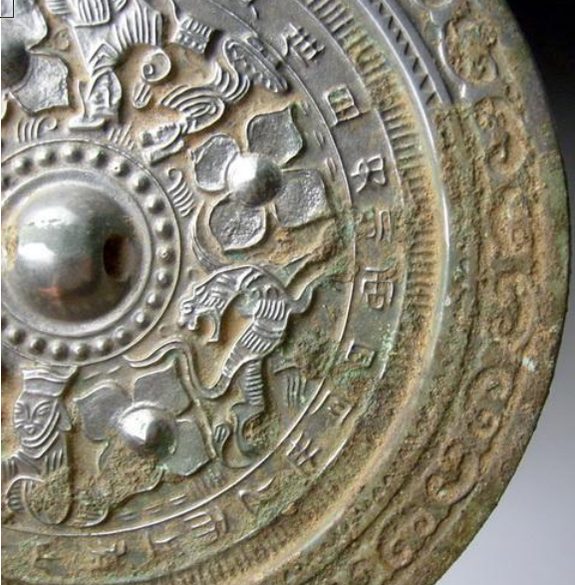

# Han Dynasty dragon&tiger grass inscriptions bronze mirror 7inch*780g